Advance Laboratory: Blackbody Radiation

Mesuga, Reymond R., Ramos, Lian Angelo B., and Tupas, Jason Carl Martin A.
Department of Physical Sciences, College of Science
Polytechnic University of the Philippines, Manila
rrmesuga@iskolarngbayan.pup.edu.ph

Abstract
Blackbody Radiation is a term used to describe the relationship between an object's temperature, and the wavelength of electromagnetic radiation it emits. A black body is an idealized object that absorbs all electromagnetic radiation it comes in contact with. It then emits thermal radiation in a continuous spectrum according to its temperature. This paper aims to show that Planck’s Radiation formula reduces to Reyleigh-Jeans formula at frequencies approaching zero and Ray-Jeans formula diverge towards infinity as frequency approaches infinity.

1. Introduction

Blackbody radiation, sometimes called cavity radiation, refers to the behavior of a system that absorbs all radiation that is incident upon it and then re-radiates energy. This re-radiated energy is characteristic of the system and doesn't depend on the energy that is hitting it. The radiated energy depends strongly on the temperature of the object instead. The object on which the radiation is incident is a special type of object known as a blackbody, a theoretically ideal radiator and absorber, which absorbs all radiation that is incident upon it.

While there's no such thing as a perfect blackbody, most solid objects are sufficiently close to being a blackbody that they can be treated as being 'close enough'. The sun giving off sunlight, for example, can be treated as a perfect blackbody. The Earth's atmosphere cannot be treated as a blackbody.

In classical physics, the predictions were that an ideal blackbody at thermal equilibrium would emit radiation with infinite power. This came from another law, Rayleigh Jeans Law, that expresses energy as being proportional to. This law predicted that the sum of all the energies at all wavelengths resulted in an infinite amount of energy in the system. The term "ultraviolet catastrophe" was used to refer to this paradox.
Physicist Max Planck resolved this paradox by predicting that energy came in discrete amounts, known as quanta. This is a main principle in quatum mechanics.

2. Results and Discussion
The following results were computed using Python 3.8 and a Python package Matplotlib on Jupyter Notebook. The authors used different values of temperatures T in Kelvin to help visualize the behaviour of each equations.

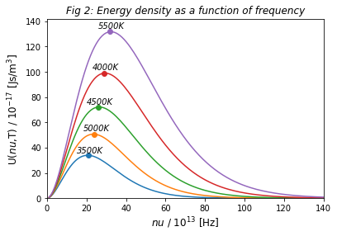
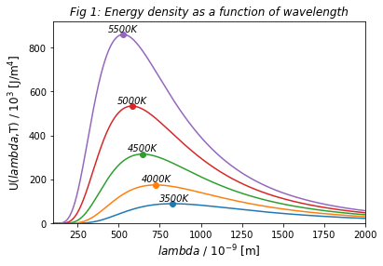

The graphs above (figure 1 and 2) shows the energy density as a function of wavelength and frequency. The densities as functions of wavelength and frequency have different equation and thus different maximums. Yet when the integrals over a range of frequencies or wavelengths are properly done (doing the correct substitutions), the energy will be the same. On the other hand, the graphs below (figure 3 and 4) show the comparison of energy density in wavelength and frequency between Rayleigh Jeans law and Plancks law.
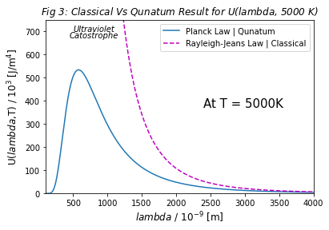
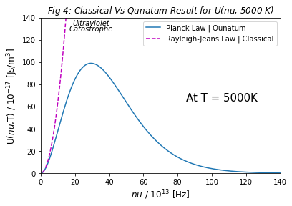

The results shows that at frequencies (nu) approaching to zero, Plancks formula equates to Rayleigh Jeans formula as shown in figure 4. Also, the Rayleigh jeans formula diverges to infinity as the frequency approaches to infinity. The mathematical considerations below explains why this happens.
The mathematical from on Rayleigh Jeans law is:

And mathematical form of planck’s radiation law is:

Rayleigh Jeans formula contains in numerator, thus clearly becomes larger and larger when v becomes large and as v approaches infinity the whole expression goes to infinity.

Now for planck’s radiation law:
Though both expressions contain powers of v in numerator, but planck’s law also have exp(v) in denominator. Since exponential grows much rapidly than a power, thus at larger values of v denominator larger than numerator and eventually v approaching to infinity will result to whole expression goes to zero. Thus at infinity planck’s expression goes to zero. The Rayleigh’s law can be written as:

Thus Rayleugh Jeans law is just power law thus it is always of the form . But Planck’s law is:

for the very small values of v above expression is

Which is Rayleigh Jeans law, Thus at small frequency scales it behaves like power law. On the other hand, for very large values of v:

Which decays exponentially. It explains why at large frequency values of planck’s law goes to zero.

Conclusion

As per classical theory, the energy radiated will become infinite as the wavelength of body
approaches zero. But this is quite contrary to the experimental results which revealed that the
energy radiated will be zero when the wavelength reaches the zero value. This contradiction is
called as the ultra violet catastrophe.

Planck resolved the solution of blackbody which is in complete argument with the
experimental data and he even resolve the concept of ultraviolet catastrophe by using the same
theory. He explained this concept by considering the energy which is emitting out is not
continuous but discrete and also explained that the energy is quantized and each quantized
energy states are called quantum states or energy levels. According to Planck’s theory, the
energy is observed in form of energy packets called quanta. Energy is absorbed when electrons
jump from one quantum state to another quantum state. The energy of each quanta is given by
the relation, E = hf.

This explanation of discrete energy levels and quantized energy levels solved the concept of
ultraviolet catastrophe showing that experimental data obeying with classical data. This theory
laid to the development of the revolutionary concept called Quantum mechanics.

References

https://chem.libretexts.org/Bookshelves/Physical_and_Theoretical_Chemistry_Textbook_Maps/Map%3A_Physical_Chemistry_(McQuarrie_and_Simon)01%3A_The_Dawn_of_the_Quantum_Theory/1.01%3A_Blackbody_Radiation_Cannot_Be_Explained_Classically

https://physics.info/planck/#:~:text=A%20blackbody%20is%20an%20idealized,as%20the%20Rayleigh%2DJeans%20law.

https://opentextbc.ca/universityphysicsv3openstax/chapter/blackbody-radiation/

